**1.Explain DAX.**

**Ans.-** DAX stands for **Data Analysis Expressions** i.e. such expressions or formulas that are used for data analysis and calculations. These expressions are a collection and combination of functions, operators, and constants that are evaluated as one formula to yield results (value or values). DAX formulas are very useful in BI tools like Power BI as they help data analysts to use the data sets they have to the fullest potential.There are 200+ functions in dax. The function of dax are SUM, WEEKDAY,WEEKNUM,CALENDARAUTO,DATE,etc.and many other.

With the help of the DAX language, analysts can discover new ways to calculate data values they have and come up with fresh insight.

The following are some key points about DAX :

DAX is a functional language i.e. its complete code is always a function. An executable DAX expression may contain *conditional statements, nested functions, value references,* etc.

* DAX formulas have two primary data types; Numeric and Non-numeric or Others. The numeric data type includes *integers, decimals, currency,* etc. Whereas, the non-numeric consists of*strings and binary objects*.
* DAX expressions are evaluated from the innermost function going to the outermost one at the last. This makes formulating of a DAX formula important.

You can use values of mixed data types as inputs in a DAX formula and the conversion will take place automatically during execution of the formula. The output values will be converted into the data type you instructed for the DAX formula.

Importance of DAX in Power BI

It is natural to think why DAX is so important to learn for working efficiently on Power BI. Well, as we have seen in our previous tutorials, making reports using the functionalities of*data importing,* *transforming and*[*visualizing in Power BI*](https://data-flair.training/blogs/power-bi-custom-visualization/) is a smooth experience. A user needs to have basic knowledge of Power BI Desktop to create a decent report with all the available data. But, if you want to level up and use advanced calculations in your Power BI reports, you need DAX.

Let’s say you want to make a visual to analyze growth percentage across different states of a country or need to compare year-over-year growth/sales. The data fields that you import in a data table are generally not enough to be used for such purposes.

For this, you need to make new measures using DAX language. In this way, you can create new measures, use them for creating exclusive visualizations, and have unique insights into data. With such unique insights into data, you can have fitting solutions for the business problems that you might miss with the usual way of analysis. Thus, DAX makes data analysis using Power BI, a smart and intelligent approach.

**2.Explain datasets, reports, and dashboards and how they relate to each other?**

**Ans.-**

Datasets:

A Power BI Dataset is a series of Power Query queries that have been shaped in a DAX model. Each dataset can combine different files, database tables and online services all into one tabular model.  In our cookie analogy, these are all different “ingredients”.

Unlike SSRS, a dataset in Power BI does not represent a single table or query of data. A dataset should be considered more like a “flavor” of data used to accomplish a specific type of reporting: financial, operational, HR, etc. So in our analogy, the dataset is the “raw dough”.

So in Power Query, you are going to have a set of queries which each combine a data source with a usually linear set of transformations.

[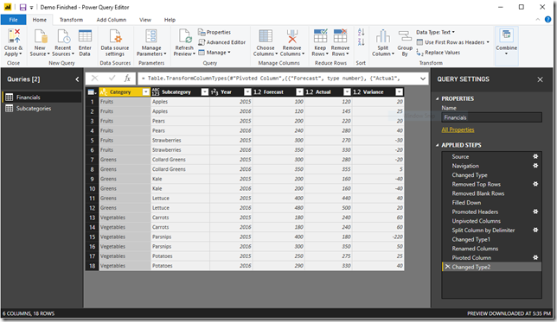](https://www.sqlgene.com/wp-content/uploads/2018/10/image.png)

Then, in DAX, you are going to take each of those outputs and combine them into a model. This consists of defining relationships between the outputted tables and adding business logic via calculated columns and measures.

[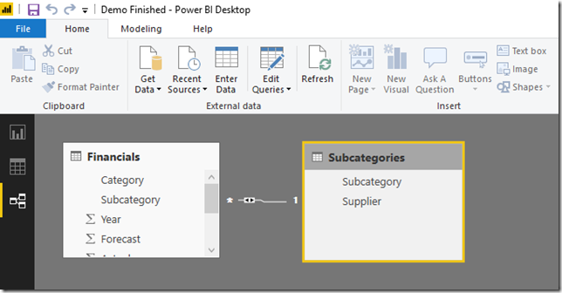](https://www.sqlgene.com/wp-content/uploads/2018/10/image-1.png)

Reports:

A power BI report is a series of visualizations, filters and static elements on a canvas. Power BI reports are saved as a single PBIX file and connect to a single dataset. Remember, a Power BI dataset can have many data sources.

[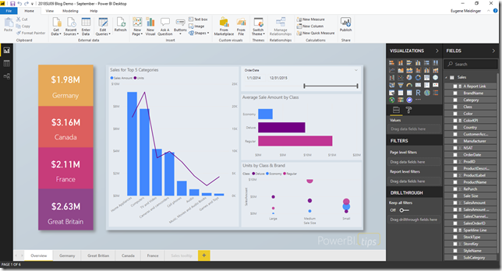](https://www.sqlgene.com/wp-content/uploads/2018/10/image-2.png)

Each report can have multiple sheets, just like an Excel workbook. In our analogy, this is us placing our “cookies” on multiple “cookie sheets” making one big batch, all of the same “flavor”.

Dashboards:

In Power BI, dashboards are a way of pulling together visualizations from various reports. When you think dashboard, you are probably thinking something like Microsoft’s [definition](https://docs.microsoft.com/en-us/power-bi/consumer/end-user-dashboards): “A Power BI **dashboard** is a single page, often called a canvas, that uses visualizations to tell a story. Because it is limited to one page, a well-designed dashboard contains only the most-important elements of that story.”

However, if you look at the report example above, it probably fits that definition. It is not a Power BI Dashboard. In Power BI, a dashboard is tool for pinning visuals from different reports and other sources of data.

[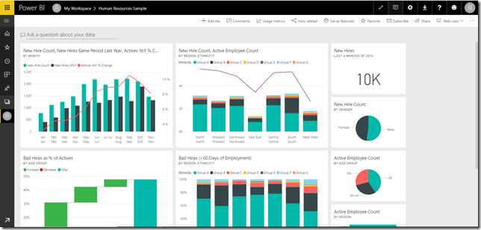](https://www.sqlgene.com/wp-content/uploads/2018/10/image-3.png)

In my opinion, a Power BI Dashboard is as much a tool for **organization** and **navigation**, as it is for actual reporting. I think that’s the real value add with Power BI dashboards.

**3.How reports can be created in power BI, explain two ways with Navigation of each.**

**Ans.** – The reports can be created in Power BI by following below steps –

1. In the navigation pane in the Power BI service, you can select the **Create** button that opens a page where you can select your data source. It's also accessible from the **New report** button on Home.

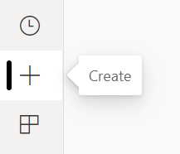

1. Currently, we only support creating a report based on an existing dataset, or pasting or manually entering data directly in a table. Over time you'll see other sources, such as uploading an Excel file.

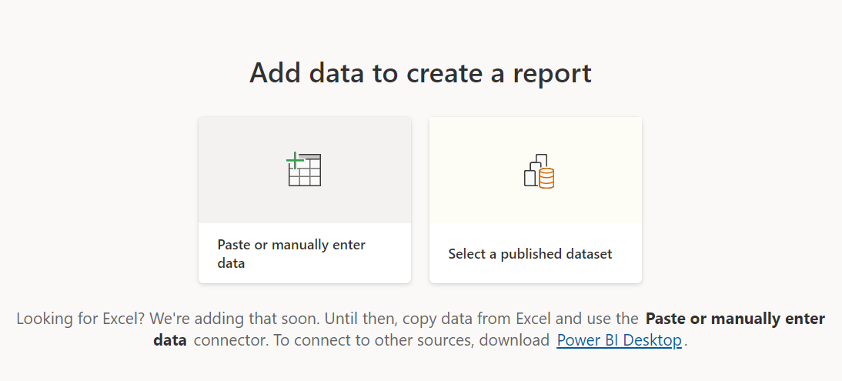

1. When you choose to paste or manually enter data, you get a grid that you can start to type into. You can also paste data by using Ctrl + V or the context menu.

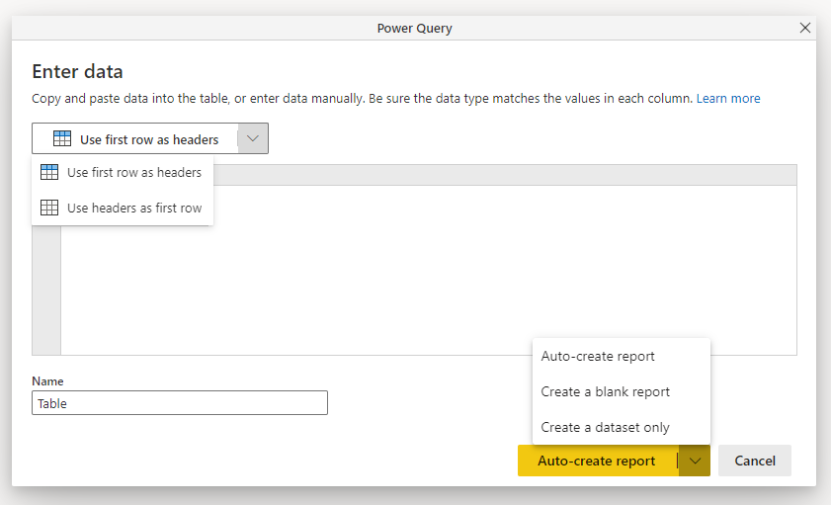

1. You can use the context menu to add and remove columns. If your pasted data includes a header row, select **Use first row as headers** to automatically promote the first row to the header row. Power BI automatically detects the data types, but you have the option to set them manually. Select the **Data type** button next to the column name.

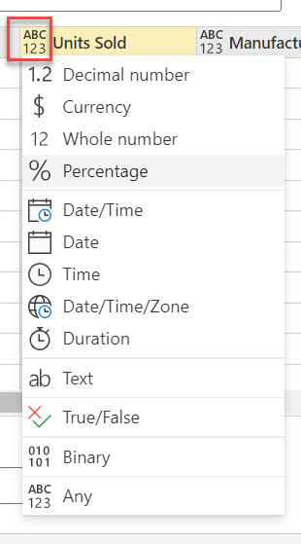

1. As you go through the creation process, Power BI creates a new dataset for you, and auto generates a summarized view of your data.
2. Changing the data you see in the report is easy, too. Use the **Your data** pane to add or remove fields from the report. Select and deselect fields to update what you want to measure and analyze. Power BI automatically plots meaningful charts based on your field selection.

Navigation in Power BI –

1. **Page navigator –**

On the **Insert** tab, select **Buttons** > **Navigator** > **Page navigator**.

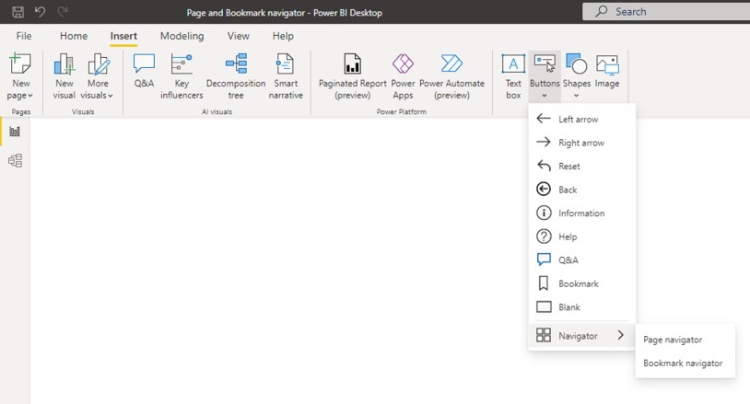

When you select the Page navigator option, Power BI automatically creates a page navigator for you.

The page navigator is automatically in sync with your report pages, meaning:

* Titles of the buttons match the page display names.
* Ordering of the buttons matches the order of your report pages.
* The selected button is the current page.
* As you add or remove pages in your report, the navigator updates automatically.
* As you rename pages, the titles of the buttons update automatically.

If you want to further customize the pages that show or hide in the page navigator, go to the Format navigator pane > Pages tab. There, you have the option to Show/hide hidden pages or Show/hide tooltip pages:

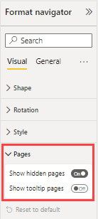

1. **Bookmark navigator** –

Before you can create the bookmark navigator, you need to [create the bookmarks](https://learn.microsoft.com/en-us/power-bi/create-reports/desktop-bookmarks) first. Additionally, create separate bookmark groups if you plan on creating different bookmark navigators within the same report.

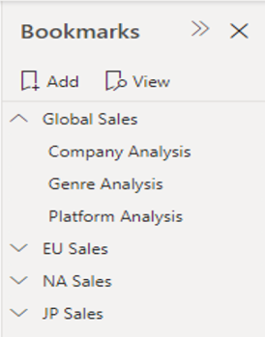

Once you’ve created your bookmarks, select the **Bookmark navigator** option.

On the **Insert** tab, select **Buttons** > **Navigator** > **Bookmark navigator**.

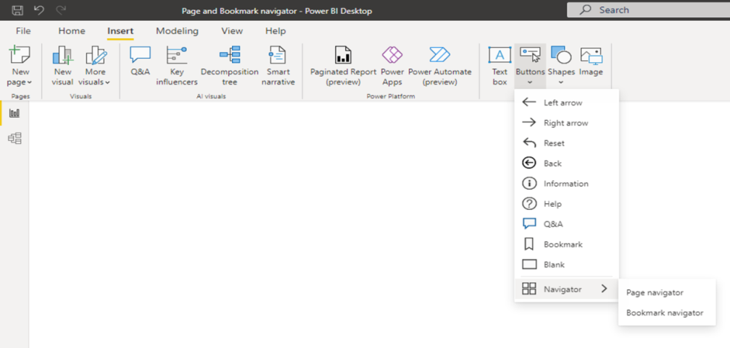

Power BI automatically creates a bookmark navigator for you.

If you want to further customize the bookmarks that show or hide in the bookmark navigator, go to the Format navigator pane > Bookmarks tab:

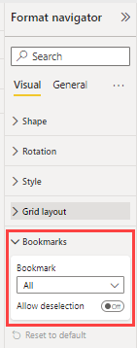

By default, all bookmarks are shown in the bookmark navigator; however, you can create and select a specific bookmark group to show only the bookmarks within that group.

Once you have bookmarked the deselected state, turn on Allow deselection and select the bookmark that you want to launch on deselection. In this case, that bookmark is named *No filter*.

If the bookmark that you’re using for deselection is within the bookmark navigator already, you can choose to hide the deselection bookmark within the navigator if you don’t want to show it:

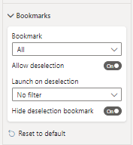

**4.How to connect to data in Power BI? How to use the content pack to connect to google analytics? Mention the steps.**

**Ans**.-You can connect to Google Analytics data using the Google Analytics connector. To connect, follow these steps:

In Power BI Desktop, select Get data from the Home ribbon tab.

In the Get Data window, select Online Services from the categories in the left pane.

Select Google Analytics from the selections in the right pane.

At the bottom of the window, select Connect.  
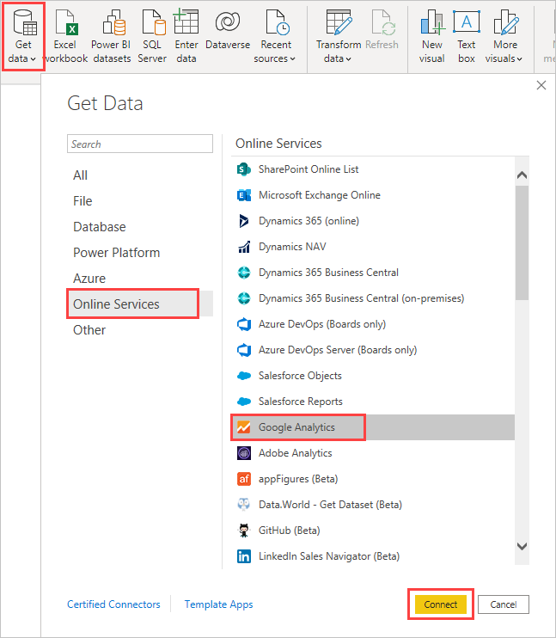

You're prompted with a dialog that explains that the connector is a Third-Party Service, and warns about how features and availability may change over time, and other clarifications.  
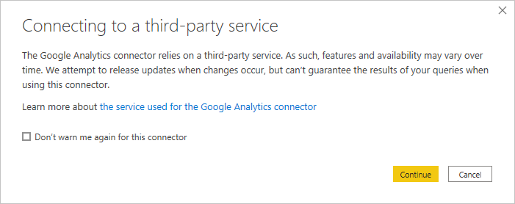

When you select Continue, you're prompted to sign in to Google Analytics.  
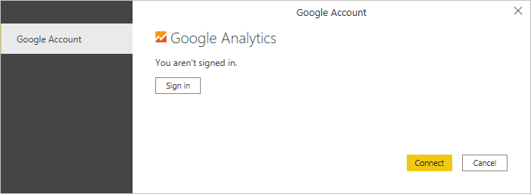

When you enter your credentials, you're prompted that Power BI would like to have offline access. This is how you use Power BI Desktop to access your Google Analytics data.

Once you accept, Power BI Desktop shows that you're currently signed in.  
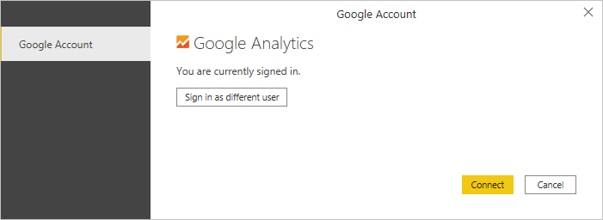

Select Connect, and your Google Analytics data is connected to Power BI Desktop, and loads the data.  
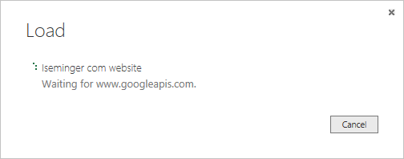

**5.How to import Local files in Power BI? Mention the Steps.**

**Ans.-**If you want to import Analytics data manually through Power BI, follow these instructions.

In Power BI, click **Get Data** in the lower left screen.

1. Under **Import or Connect to Data** > **Files**, click **Get**.

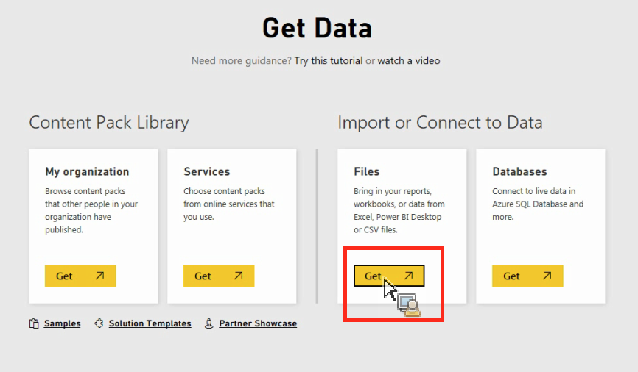

1. Click Local File.

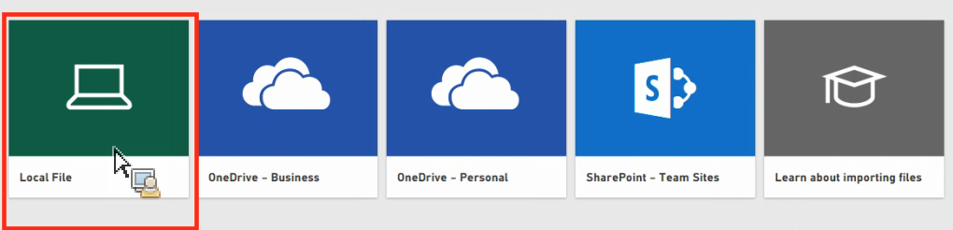

1. Choose which file to upload and click **Open**.
2. Click **Upload** under **Upload your Excel file to Power BI**.

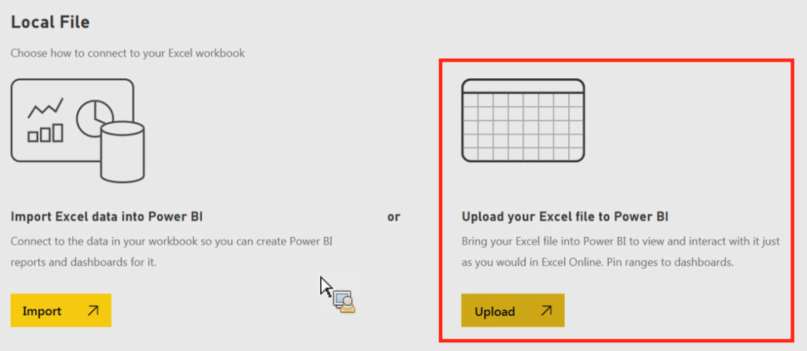

1. The message “Your file has been uploaded” should appear.

**6. In Power BI visualization, what are Reading View and Editing view?**

**Ans**. – The Power BI service has two different modes for interacting with reports: [Reading view](https://learn.microsoft.com/en-us/power-bi/consumer/end-user-reading-view) for report *business users* and Editing view for report owners and creators.

If you are a *business user*, then you are more likely to use Reading view to consume reports created by others. Editing view is used by report *designers*, who create the reports and share them with you. Reading view is your way to explore and interact with reports created by colleagues.

Even in Reading view, the content isn't static. You can dig in, looking for trends, insights, and other business intelligence. Slice and dice the content, and even ask it questions using your own words. Or, sit back and let your data discover interesting insights for you; send you alerts when data changes, and email reports to you on a schedule you set. All your data, any time, in the cloud or on-premises, from any device.

Editing view is only available to the person who created the report or to people who are assigned the member, admin, or contributor role in the workspace where the report is stored. If you share a report, the user's access will be limited to their assigned workspace role. Users who have only the viewer role will can't edit reports in the workspace.

## Functionality only available in Editing view

To help you navigate the Table of Contents, Editing view is required for the following actions:

* Creating, editing, renaming, sharing, and deleting reports.
* Adding, renaming, rearranging, and deleting report pages.
* Formatting reports.
* Adding visualizations, text boxes, shapes, and buttons to a report.
* Adding visual-level, page-level, and report-level filters and setting visual interactions.
* Creating refresh schedules.
* Using Q&A functionality to create visuals in reports.